REPORT
On
CAMPUS PLACEMENT
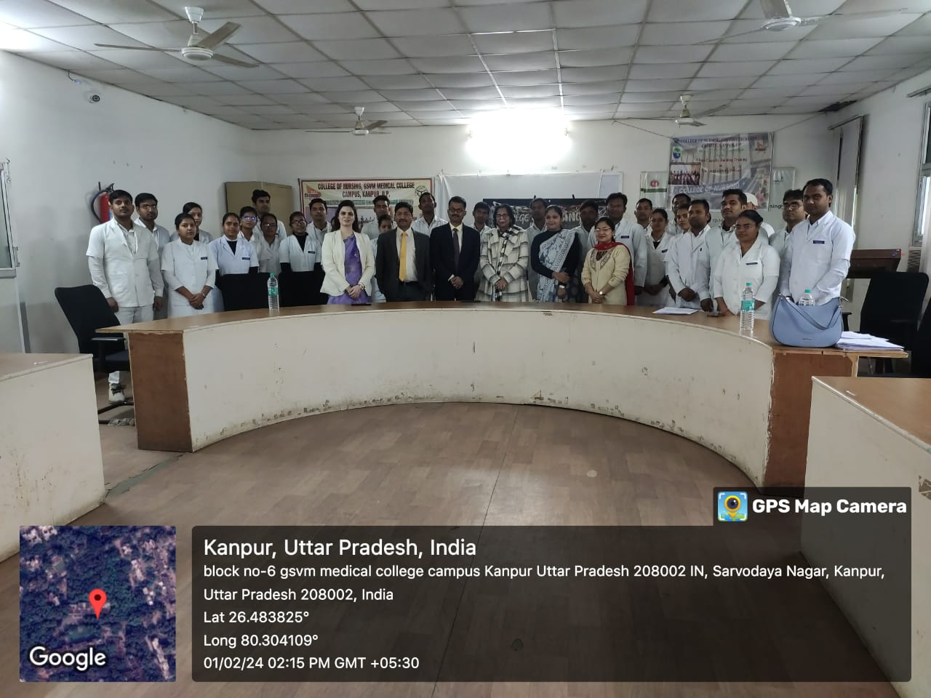

Date: 01.02.2024
Time: 9:00am-5:00 pm
Venue: GFATM Hall, CON, Kanpur
For
B.Sc Nursing, 4th year students

GOVERNMENT COLLEGE OF NURSING, GSVM MEDICAL COLLEGE KANPUR
CAMPUS PLACEMENT REPORT
Campus placement cell of College of Nursing, organized its first campus placement for B.Sc Nursing 4th year students wherein 30 students participated and cleared the written exam, followed by one to one interview session. College of Nursing had the opportunity to have leaders and heads from Regency Hospitals Ltd. for campus recruitment of the students.
First campus placement was highly successful with 100 percent students selected in campus placement for the post of “Nurse Apprenticeship”.
The program was headed under the guidance of eminent principal Lt. Col. Dr. Karesh Prasad, she is the bone behind the success of the institute at every step.
General Information:
- Date: 1st Feb 2024
- Time: 9:00 am- 5:00 p.m
- Venue: GFATM hall
- Event organizers:
  - Campus Placement Cell in-charge: Dr. Akansha Massey, Ph.D Mentor & Tutor CON, Kanpur
  - Organizing team member: Mrs. Itisha Rose Prasad, Tutor CON, Kanpur

Team for Campus Placement:
Esteemed personalities from Regency Hospital Ltd Kanpur & Lucknow came for the placement of the students. Entire team was highly humble, very supportive and motivating. They encouraged the students and conducted 15 min written exam followed by face to face interview.
The core team included:
- Mr. Hari Haran Shankar Raj, Associate Vice-president (nursing) Regencey Hospitals Ltd.
- Mr. Ravi Kumar Mishra, GM (HR) Regency Hospitals Ltd.
- Ms. Nikita Gupta, Executive HR Regency Hospitals Ltd.
Overall, first campus placement was highly successful with 100 percent students selected in campus placement. Looking forward and paving path for more such students to be selected in such renowned institutes and build a better future for them and come out as skilled nurses in serving the society and mankind.

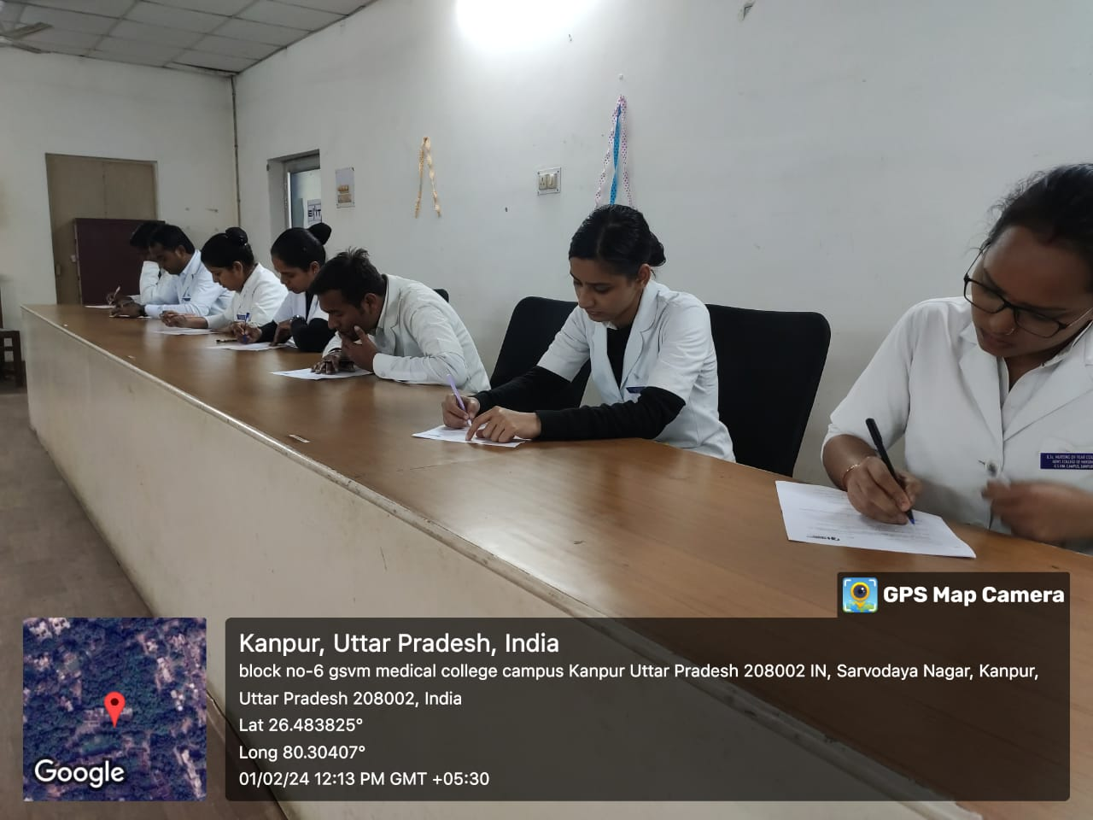
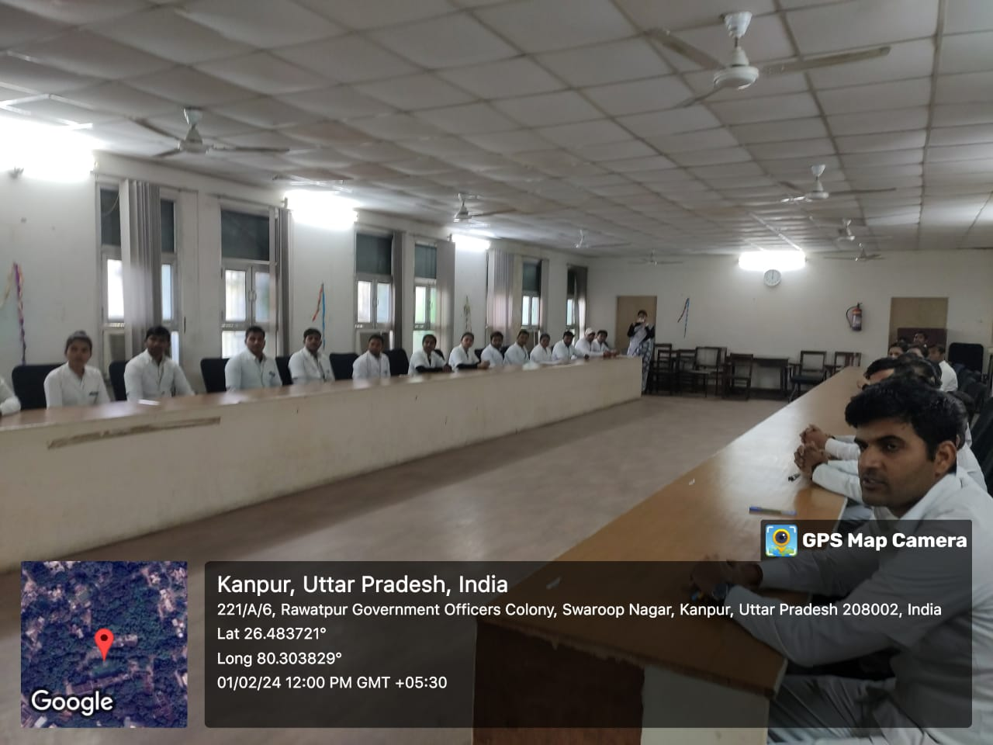
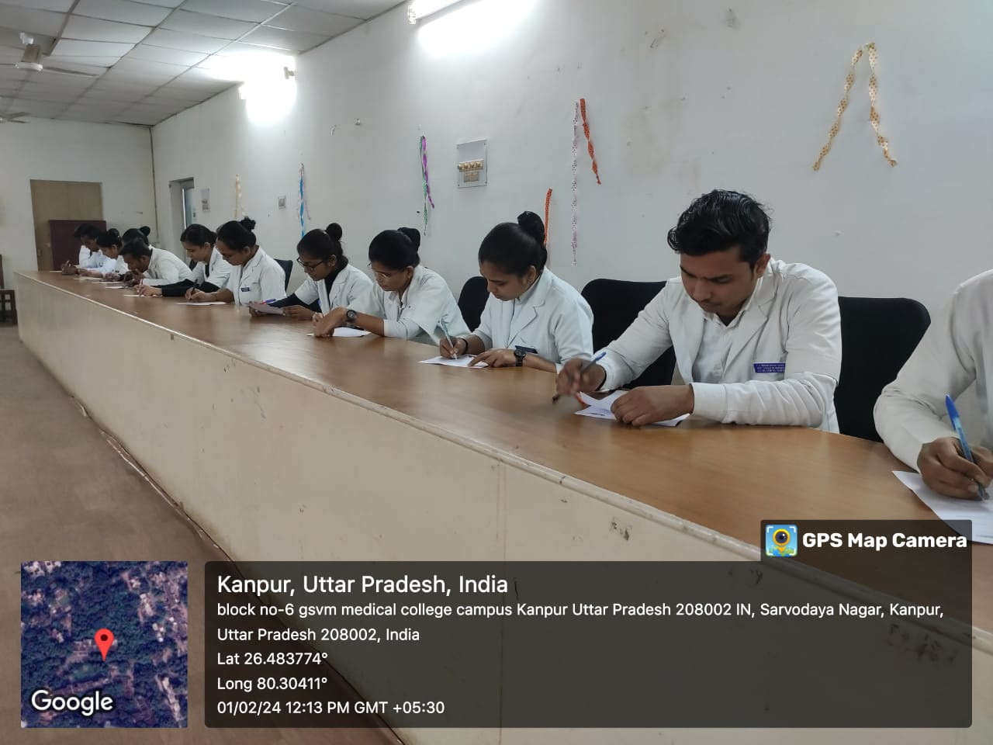
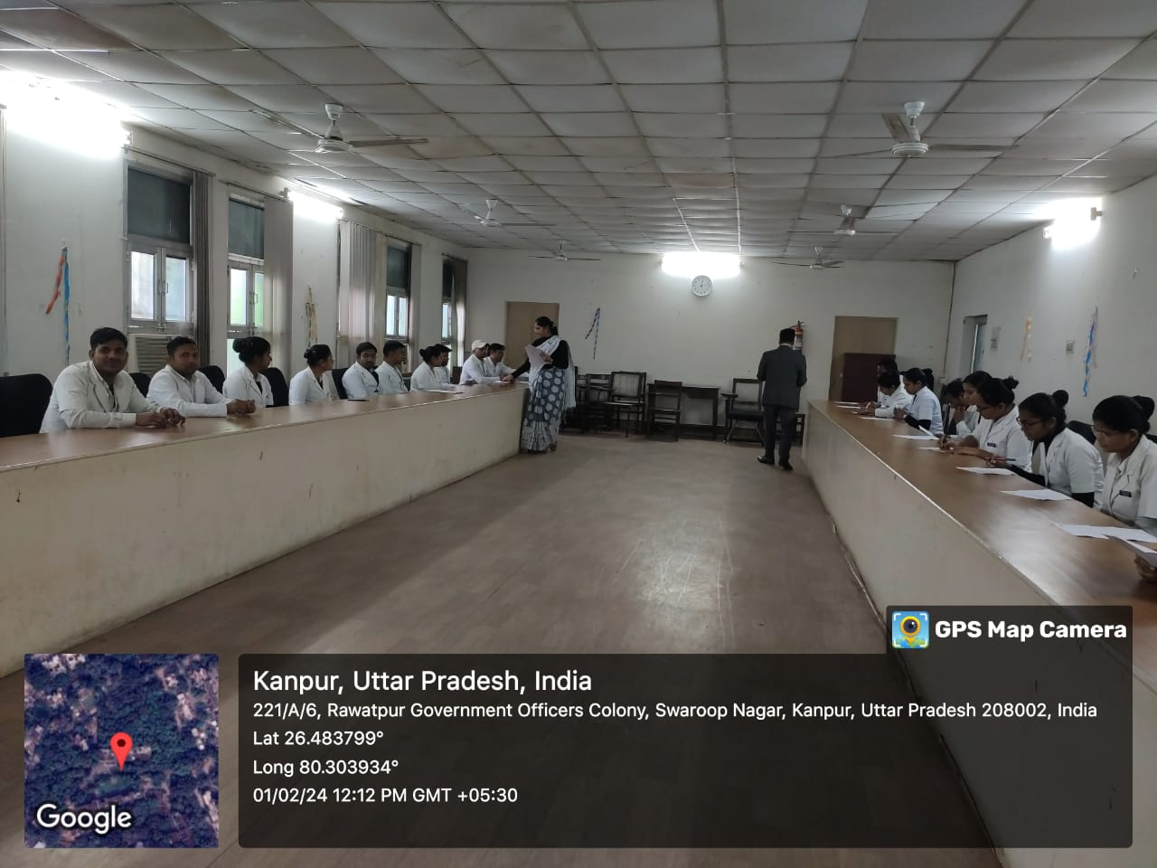
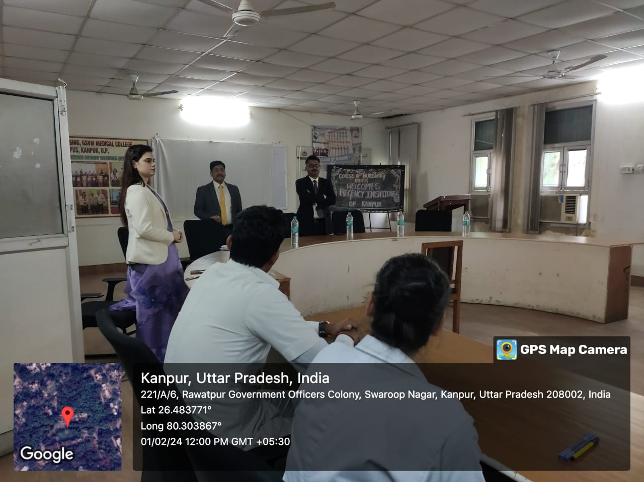
GLIMPSES OF CAMPUS PLACEMENT

